2520090013(Bathula Neha)
Week 2:
STEP 1: CREATE TABLE
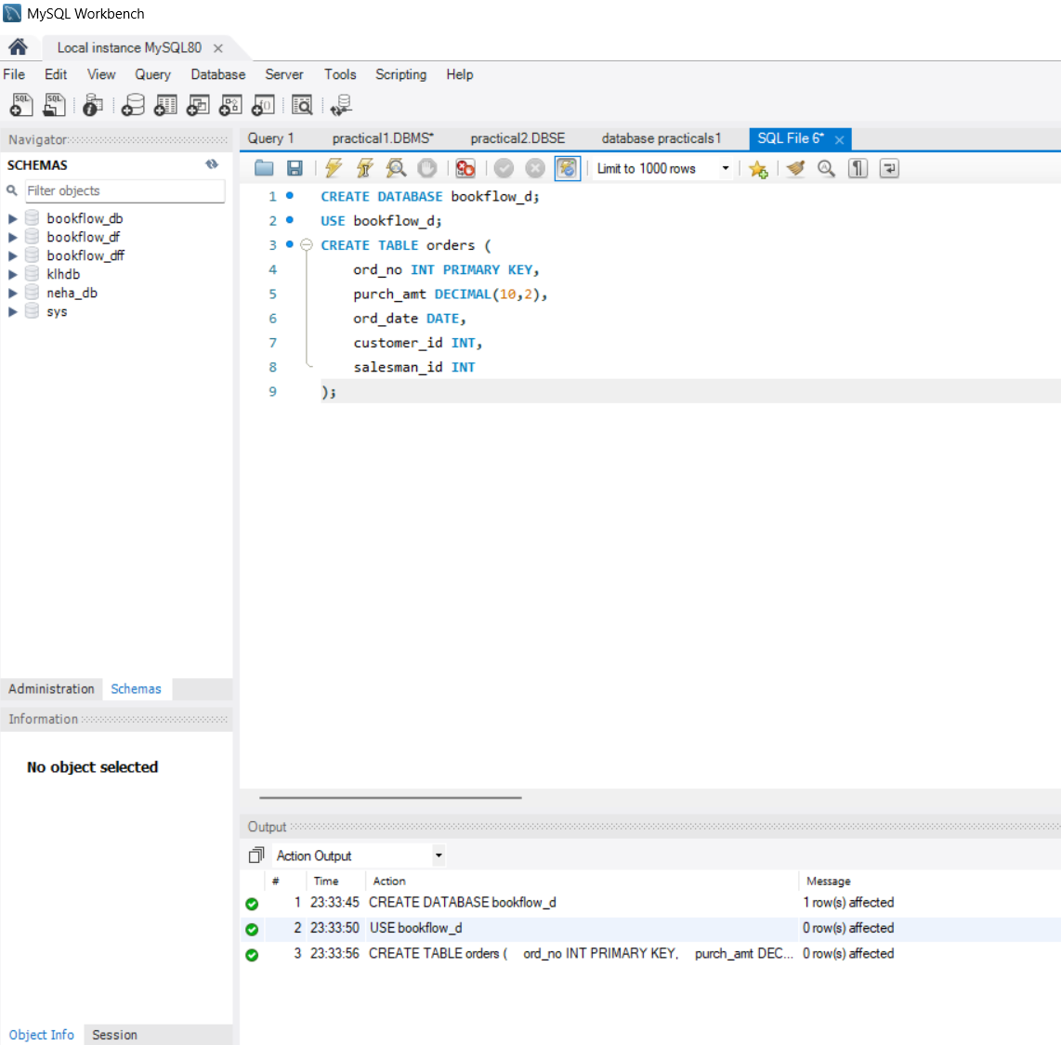
STEP 2: INSERT DATA
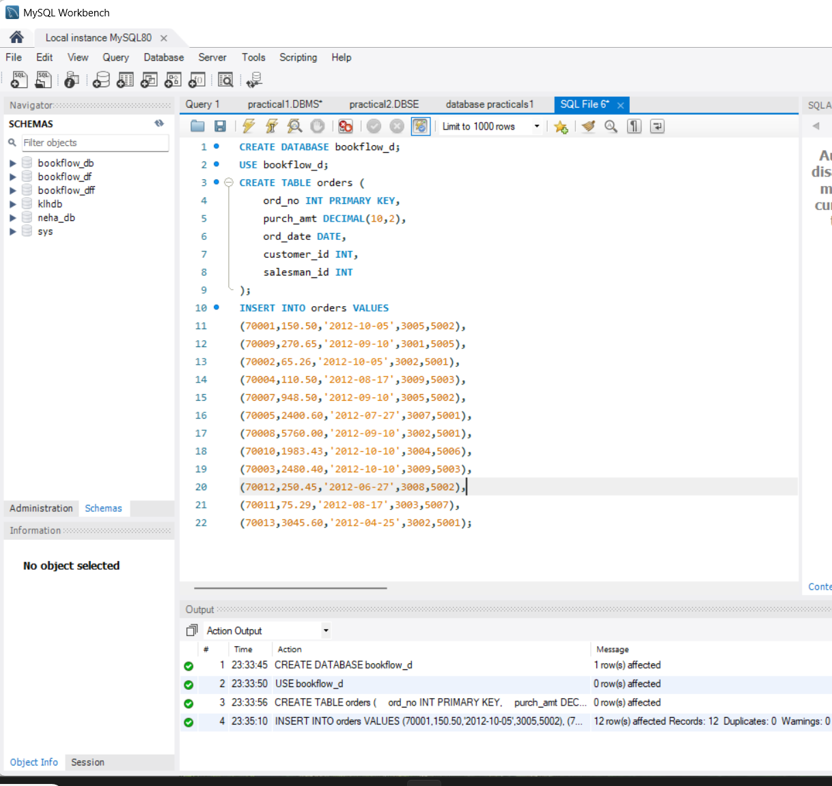
QUESTION 1 - WHERE CLAUSE
SCENARIO:
Finance wants all orders whose purchase amount is greater
than $2,000
QUESTION 2 - WHERE CLAUSE
SCENARIO:
Management wants all orders placed on 2012-09-10.
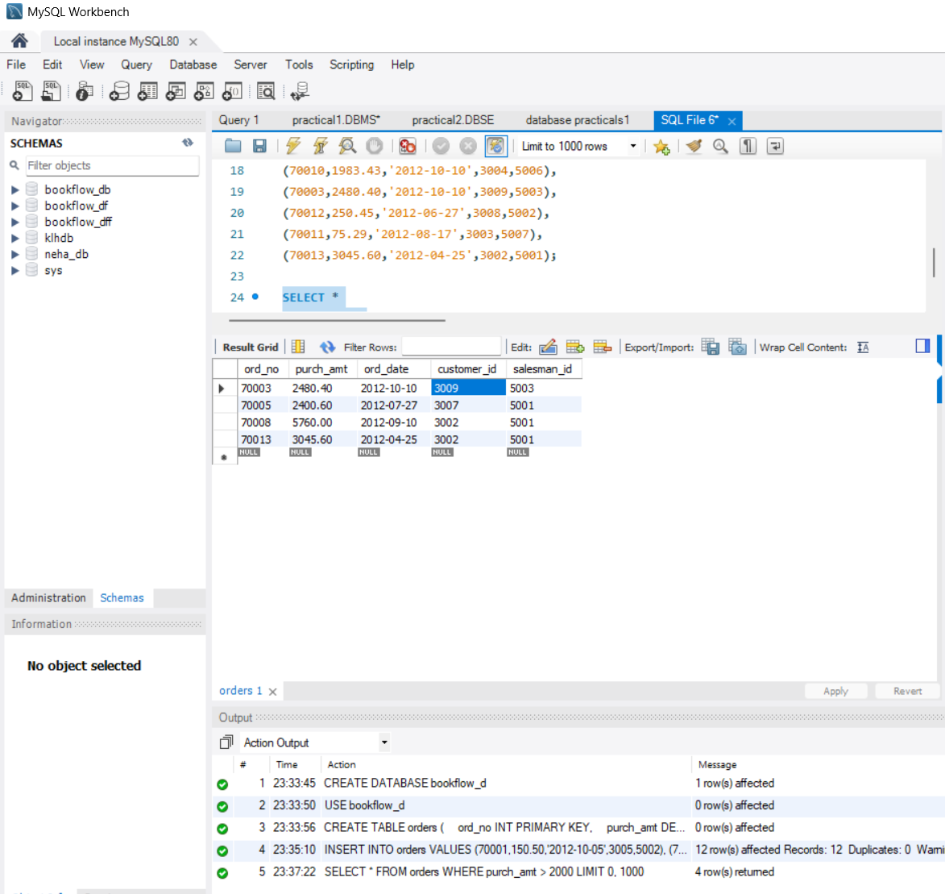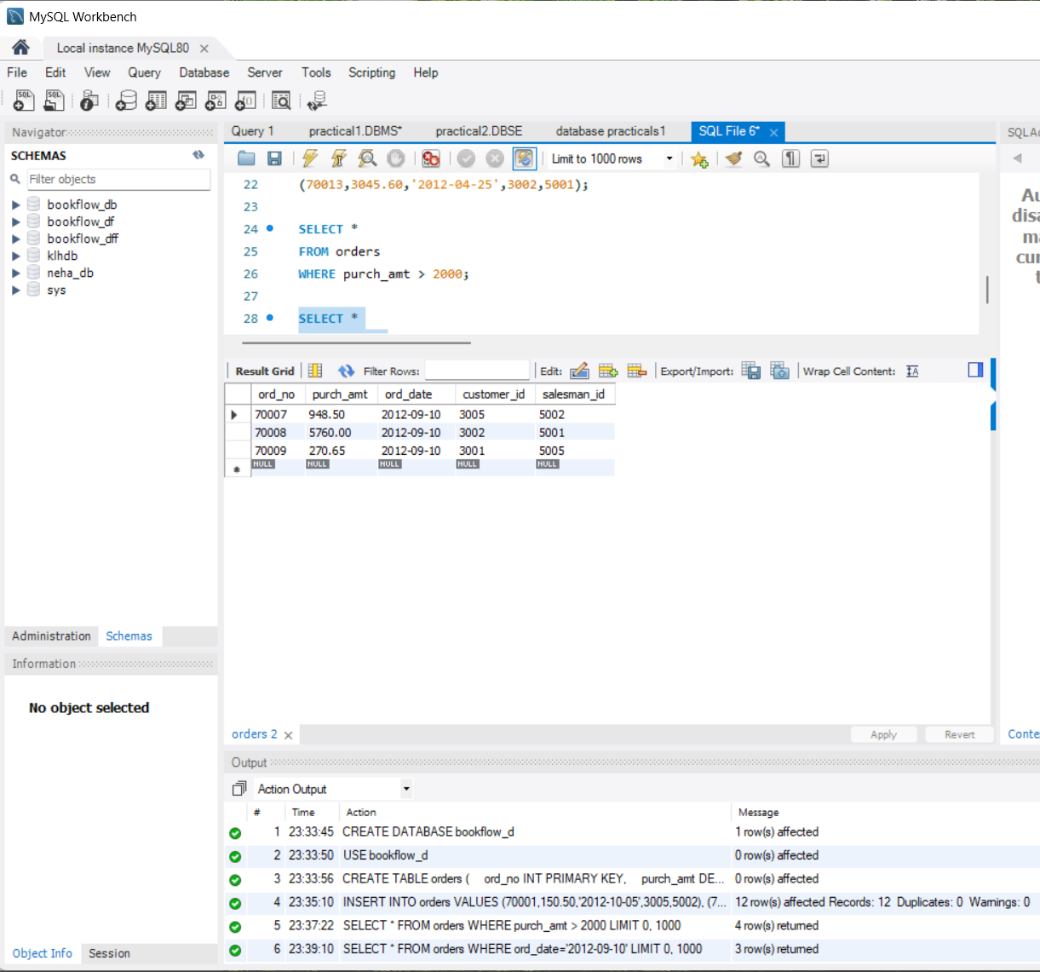
QUESTION 3 - WHERE CLAUSE
SCENARIO:
Find all orders handled by salesman 5001.
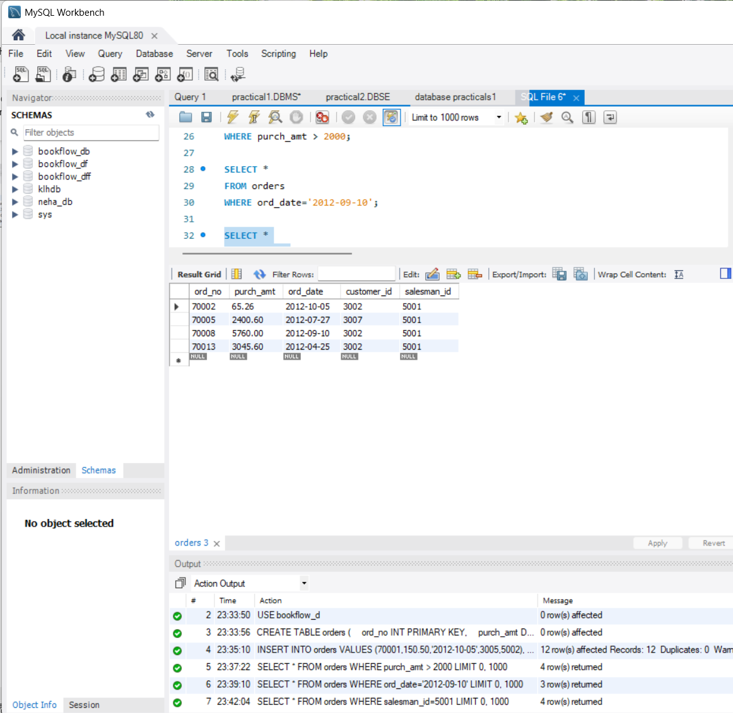
QUESTION 4 - ORDER BY
SCENARIO:
CEO wants to see orders ranked from highest amount to
lowest amount.
QUESTION 5 - ORDER BY
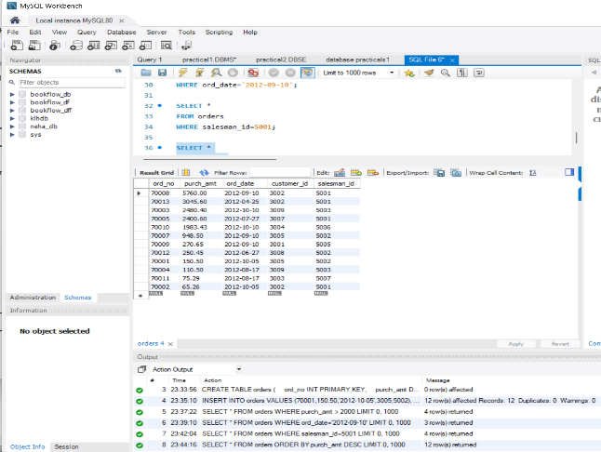
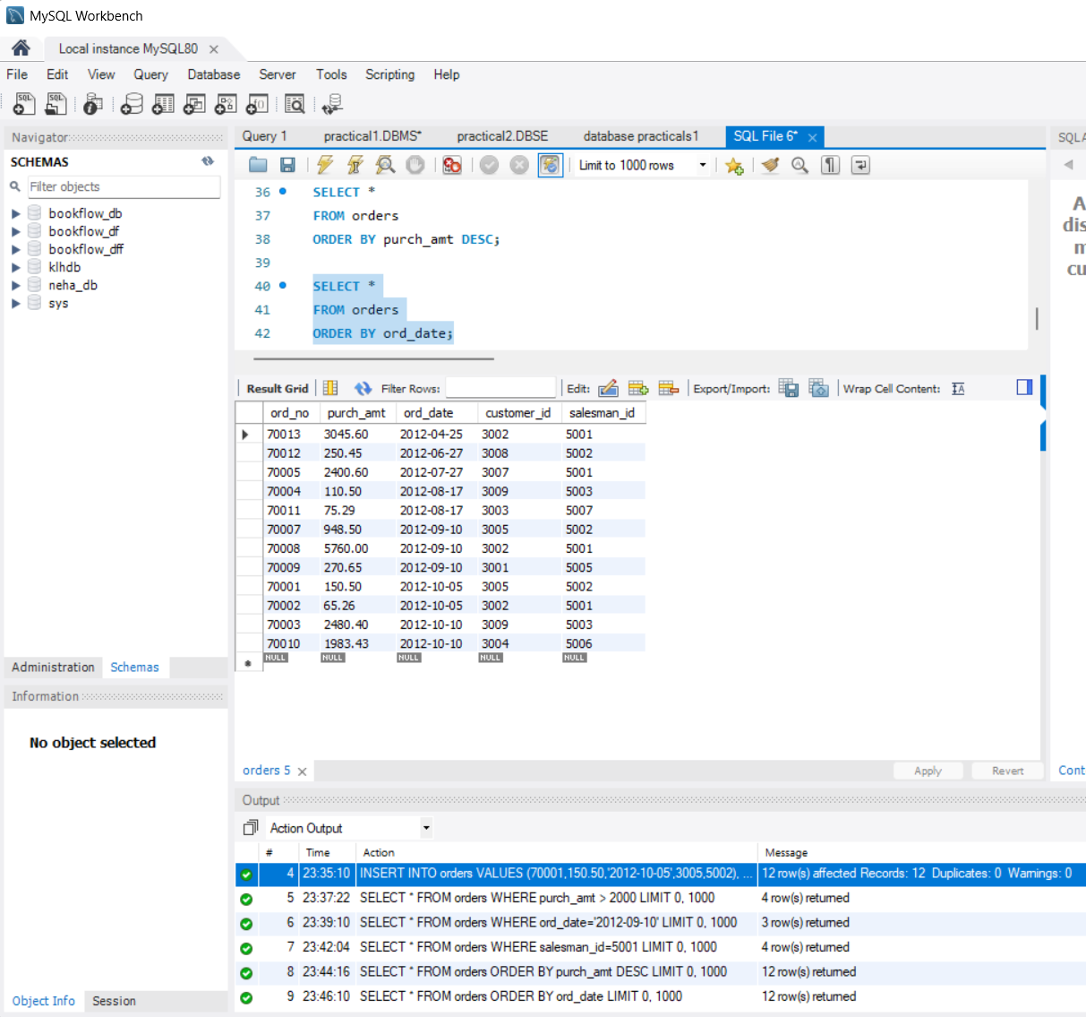
QUESTION 6 - SUM()
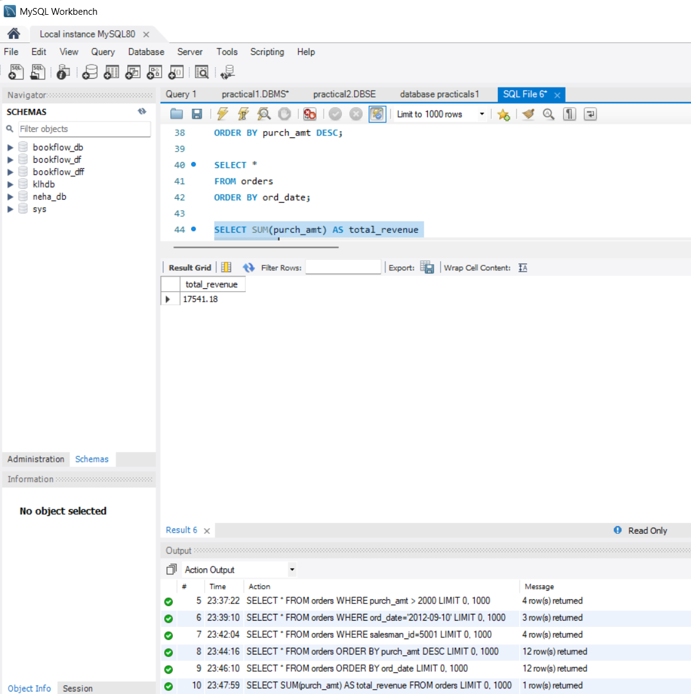

QUESTION 7 - AVG()
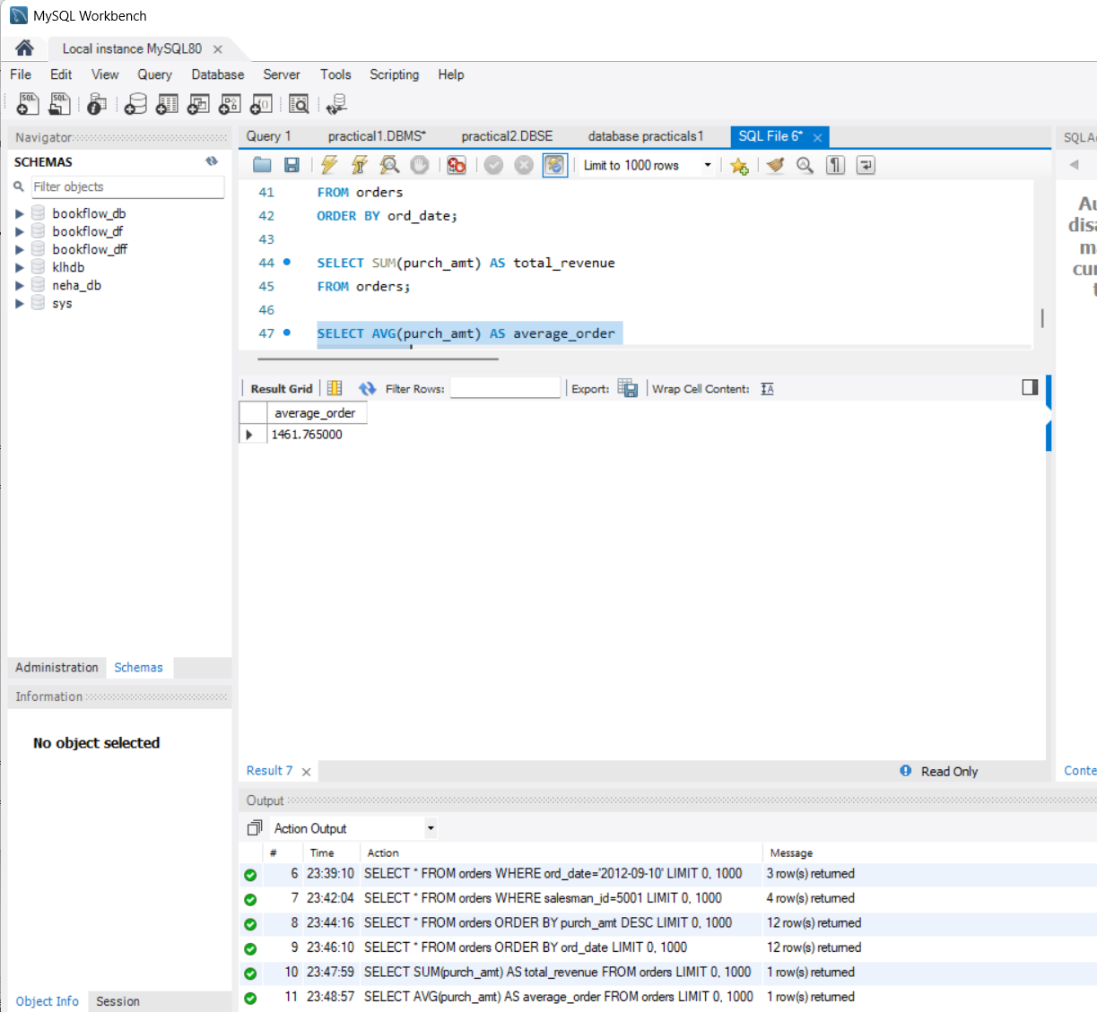
QUESTION 8 - MAX()
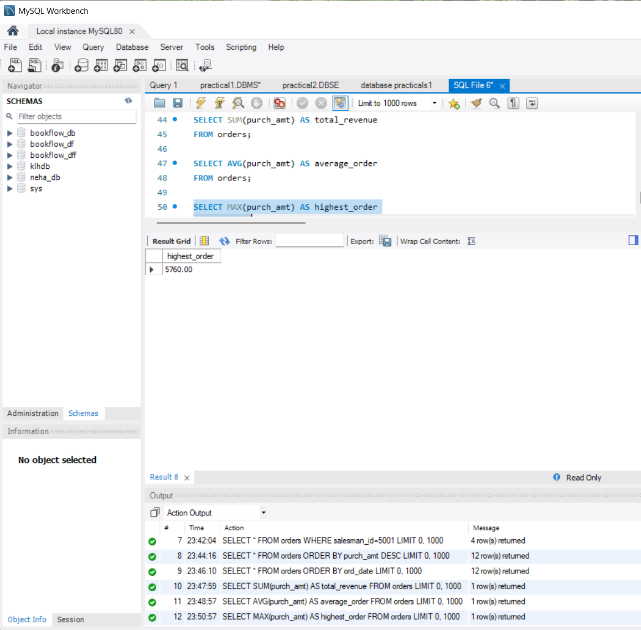
QUESTION 9 - MIN()
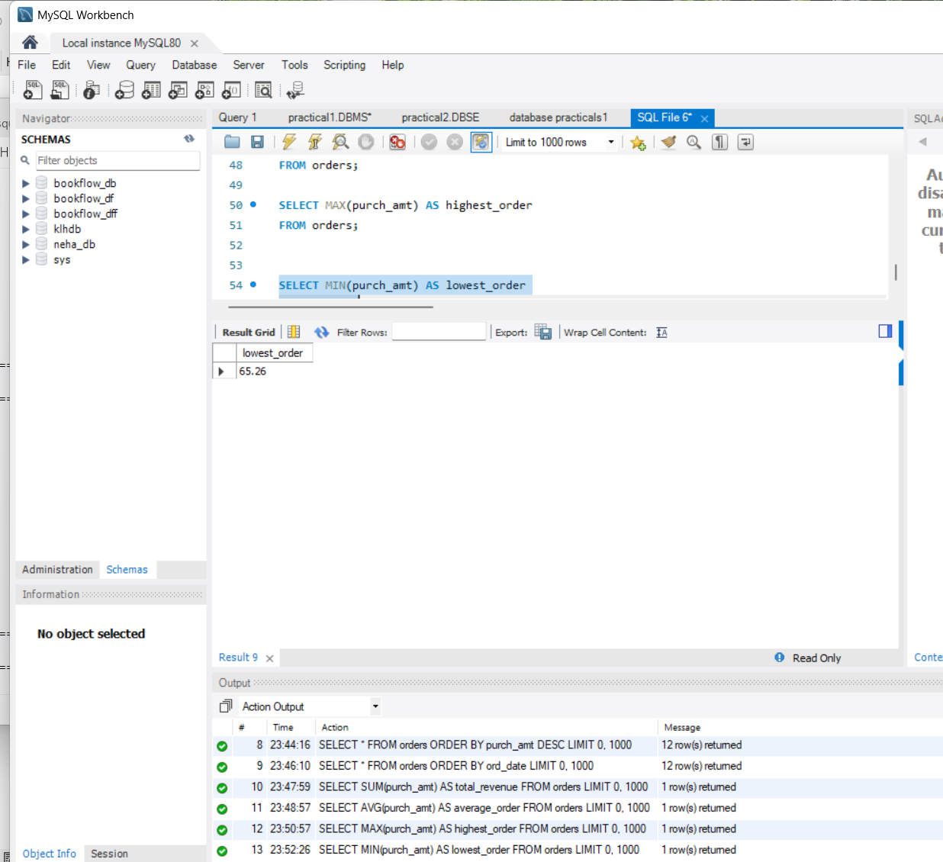
QUESTION 10 - COUNT()
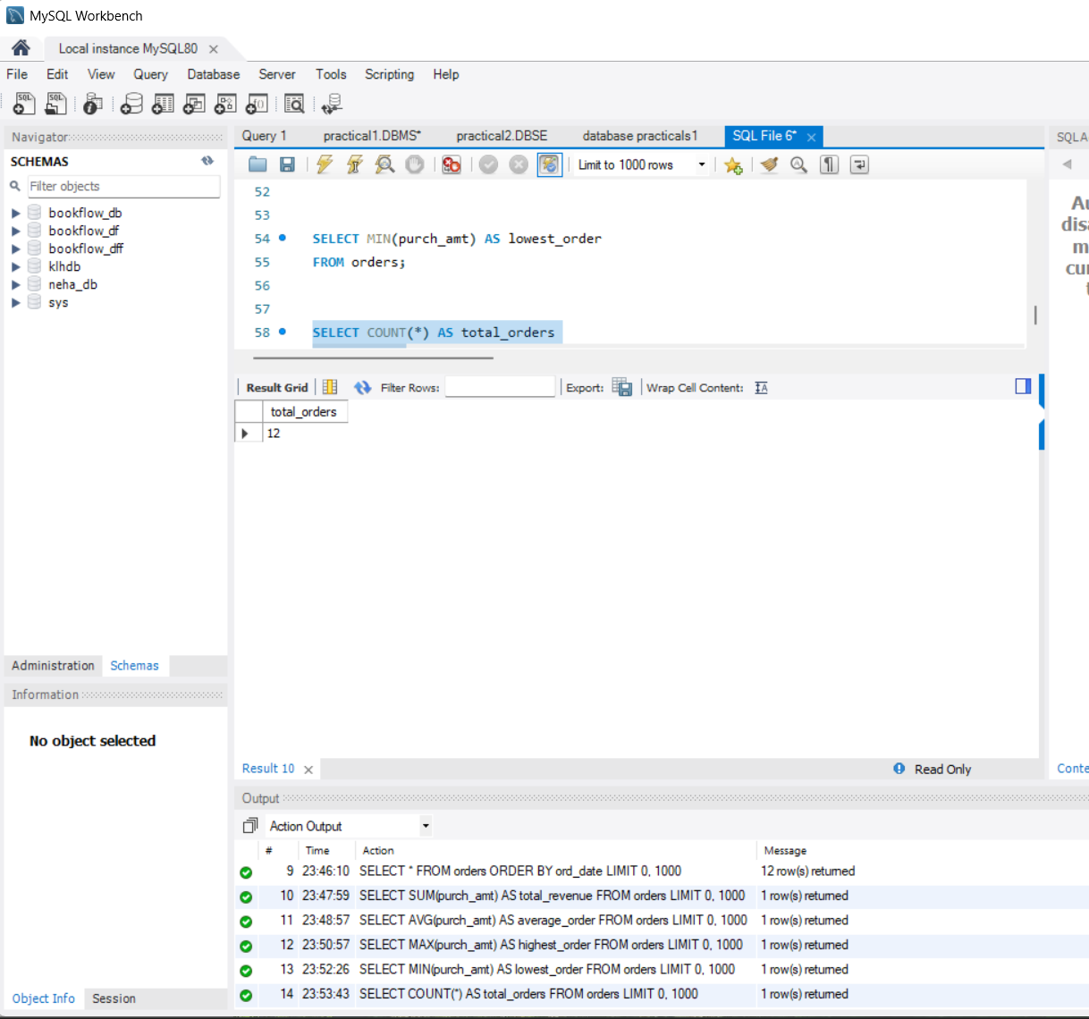
QUESTION 11 - GROUP BY
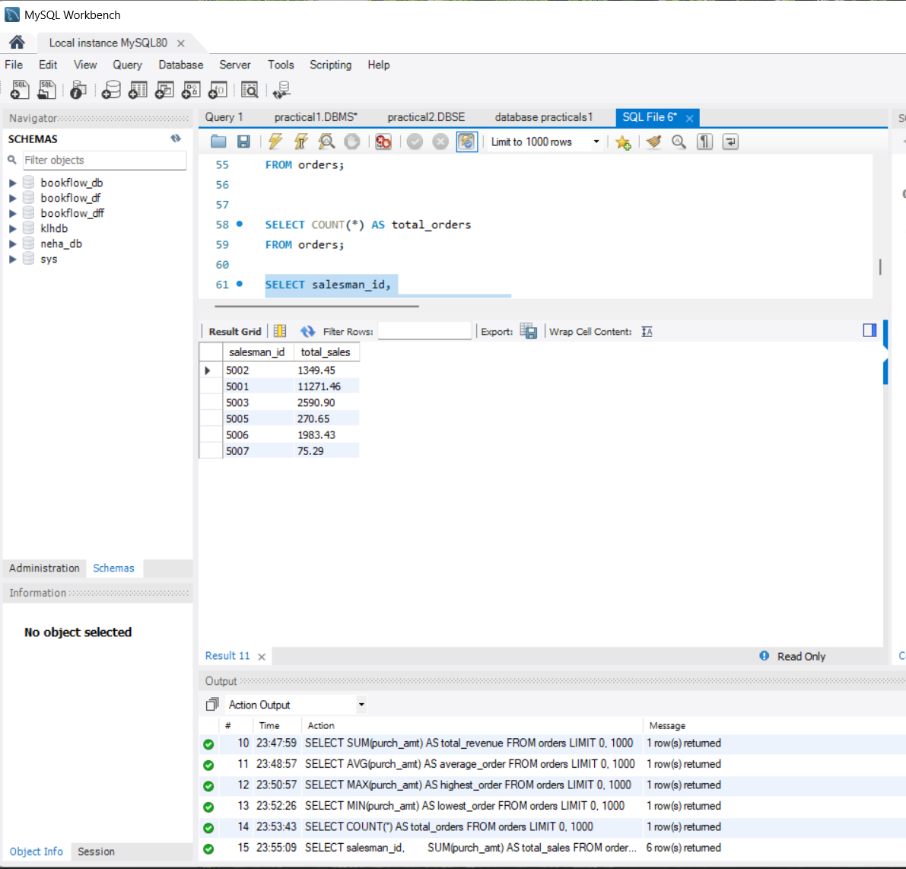
QUESTION 12 - GROUP BY
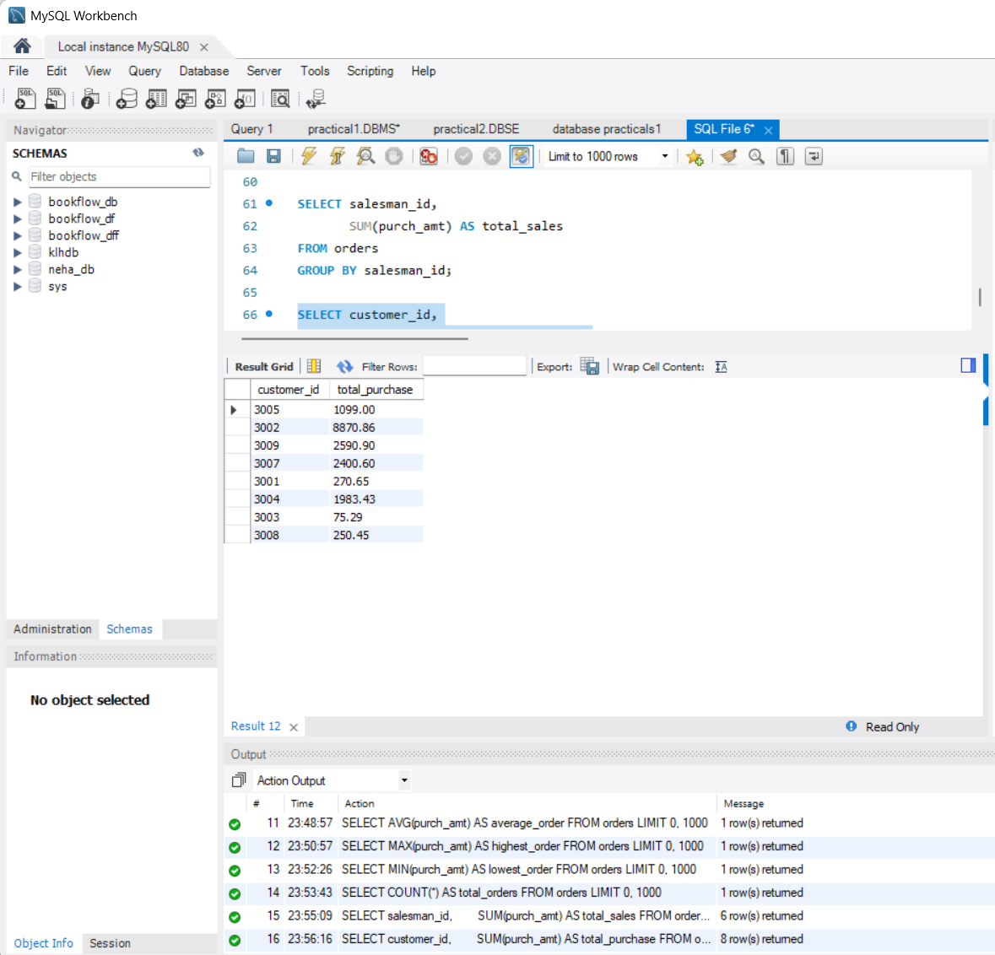

QUESTION 13 - GROUP BY + MAX()
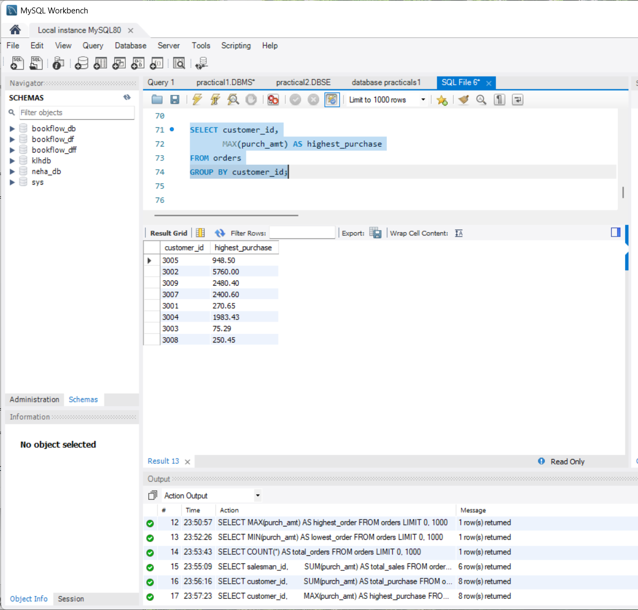
QUESTION 14 - GROUP BY + HAVING
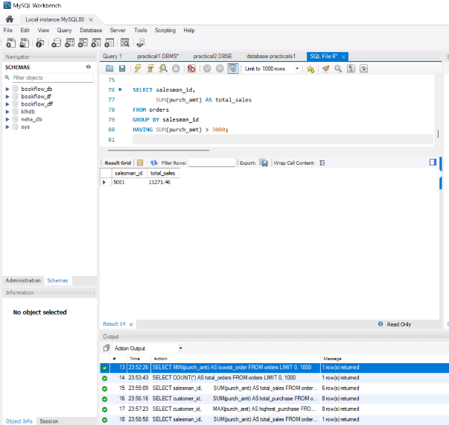
QUESTION 15 - GROUP BY + HAVING
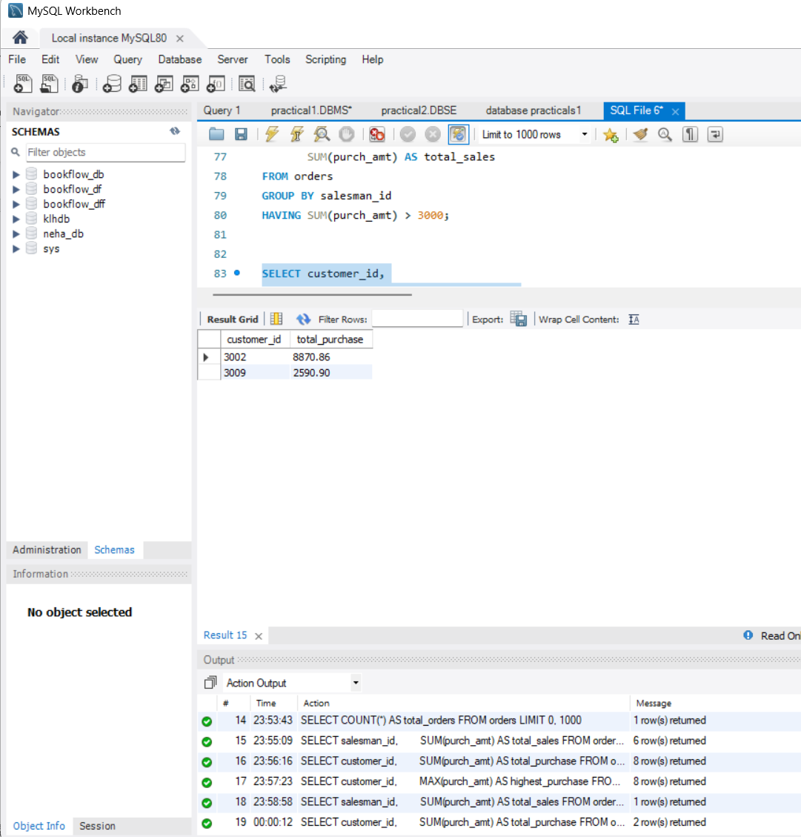
QUESTION 16 - GROUP BY + HAVING
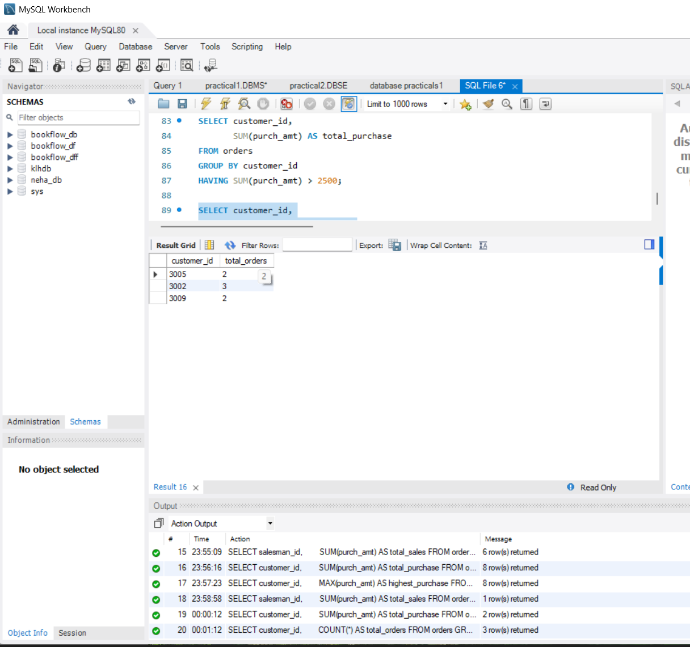

QUESTION 17 - GROUP BY + HAVING + ORDER BY
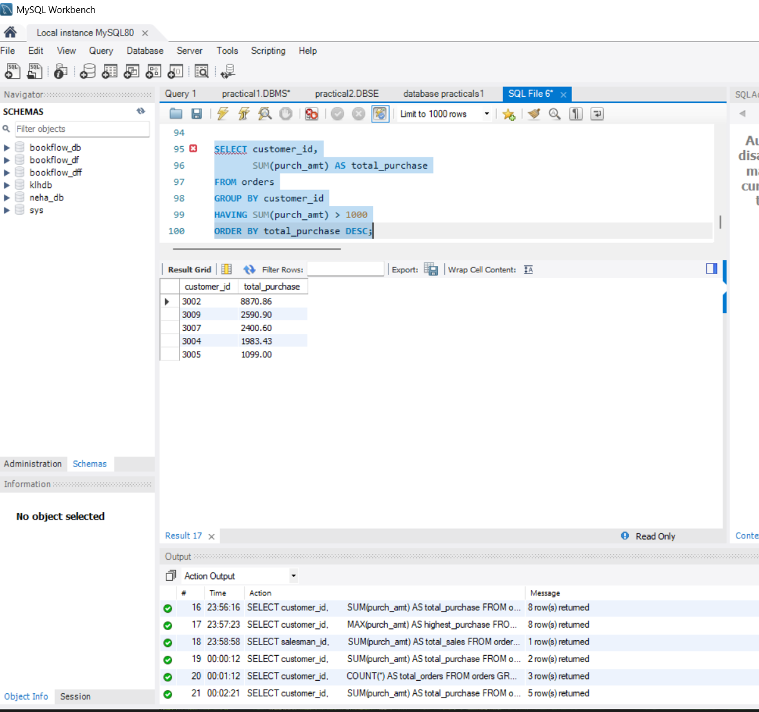
QUESTION 18 - BETWEEN + HAVING
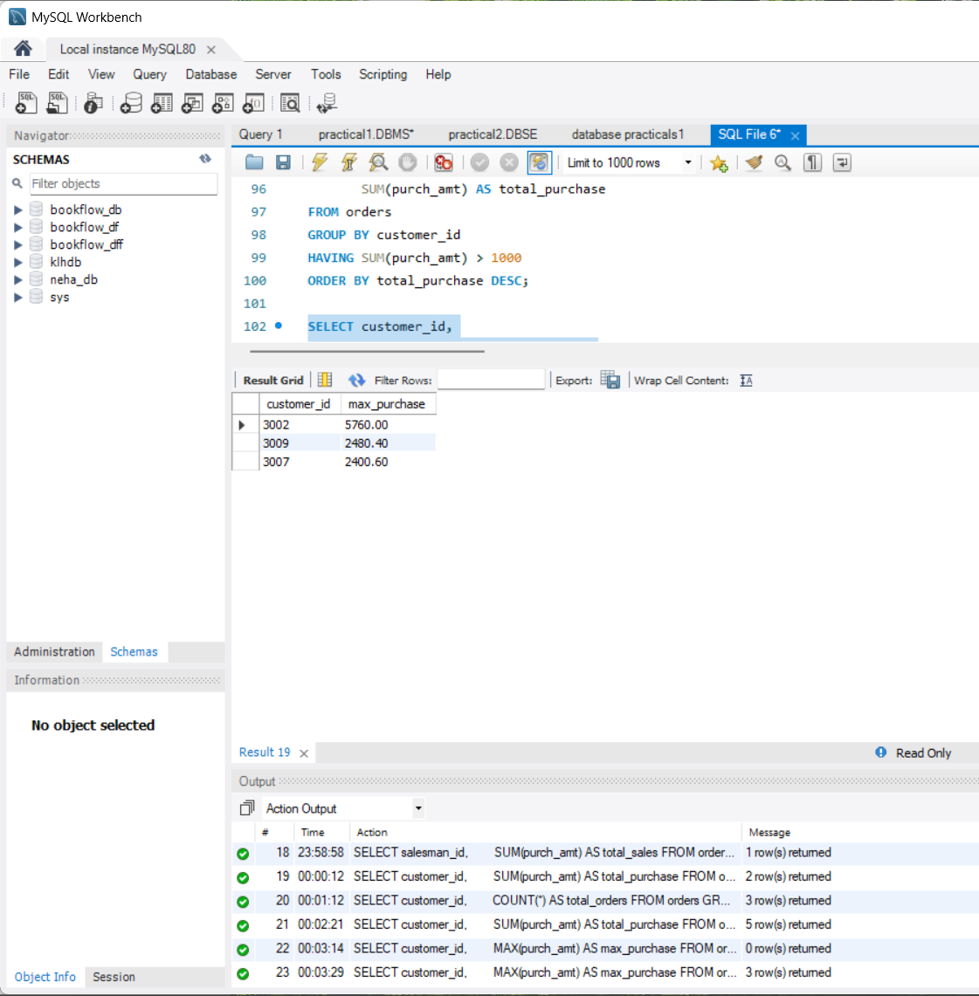
QUESTION 19 - COUNT + HAVING
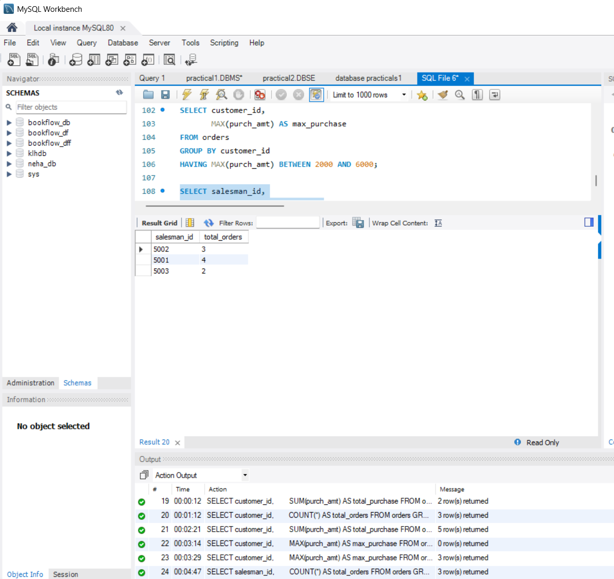
QUESTION 20 - MAX + GROUP BY + HAVING
